Backup and Restore ESXI Configurations
- The destination build number of the host matches the build from which the backup was taken.
- The UUID of the host remains the same.
p the ESXi host configuration data
- To synchronize the configuration changed with persistent storage: run this command:
  - vim-cmd hostsvc/firmware/sync_config
- To backup the configuration data for the ESXi host, run this command:
  - vim-cmd hostsvc/firmware/backup_config
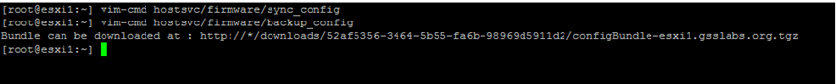
- As a result, you will receive a link to download the configBundle.tgz archive from the ESXi host. You should replace the asterisk with the IP address of your ESXi host.

Note: The command will output a URL (http://<host_fqdn_orIP>/downloads/123456/configBundle-xx.xx.xx.xx.tgz) from where you can download the backup file, either by opening it in a web browser or using other means like wget.
- The IP address of your ESXi host can be checked in the ESXi direct console interface or using the following command:
  - esxcli network ip interface ipv4 get
- From a web browser navigate to http://<host_fqdn_orIP>/downloads/123456/configBundle-xx.xx.xx.xx.tgz
In this example, the IP address of the host is 192.168.0.8
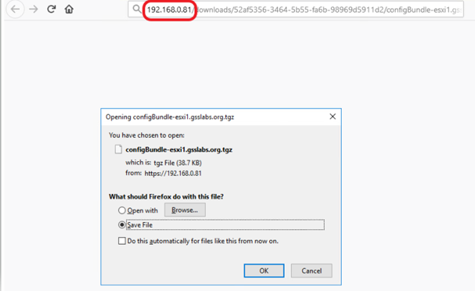
- The backup file will be in the /downloads directory (default to browser or choose to download to a specific directory) as configBundle-HostFQDN.tgz
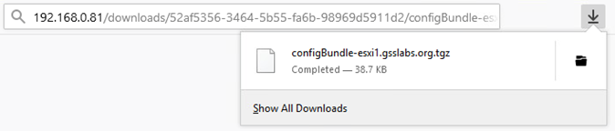
Note: The destination ESXi host must be the same build as the ESXi host configuration data to restore the configuration. The host build can be obtained using the command vmware -vl.

Restoring the ESXi host configuration data
- The configBundle-HostFQDN.tgz should be renamed as configBundle.tgz before initiating the restore command.
- Put the host into maintenance mode by running this command.
  - vim-cmd hostsvc/maintenance_mode_enter
- Copy the backup configuration file to the ESXi host or an available datastore.
- Reboot the host. This step is required; otherwise, the restore workflow might not finish completely.
- Once ESXi has rebooted, move the config bundle file to /tmp/configBundle.tgz.
- Then run this command to restore the ESXi host configuration:
  - vim-cmd hostsvc/firmware/restore_config 0
Note: Add a 1 to force an override of the UUID mismatch.
For example: # vim-cmd hostsvc/firmware/restore_config 1
- Executing this command will initiate an automatic reboot of the host after command completion.
- However, starting from vSphere 7.0 U2, the configuration could be encrypted using TPMs, in which case, the -force option will not work if the host got changed. We need the same TPM that was used on the host during the backup to restore. In other words, from vSphere 7.0U2, the override will not work if the host has TPM enabled.

